# Case Studies

Week 2 case studies.

## Case Study 1

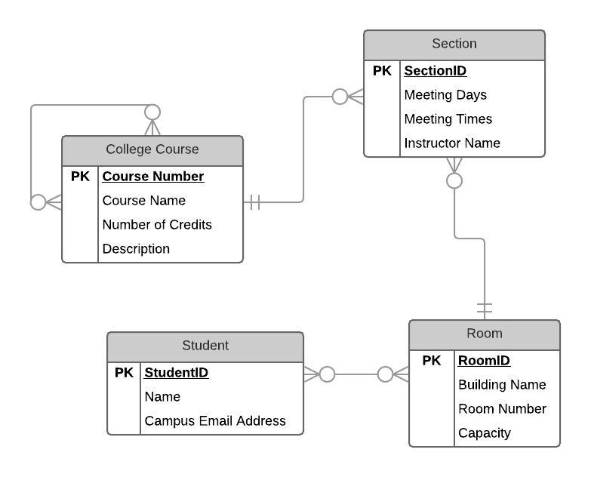

## Case Study 2

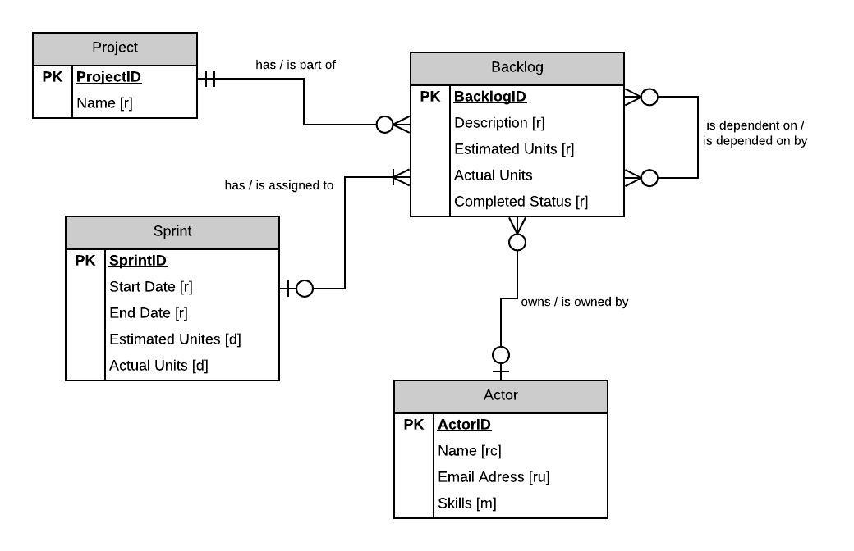

## Case Study 3

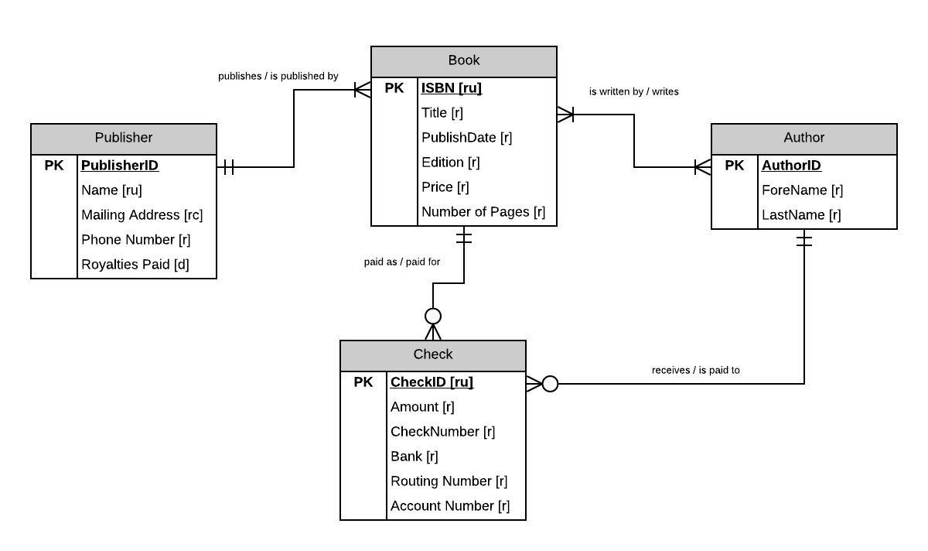

# Part 2 – VidCast Conceptual Model

